INSIGHTS ON THE MARKETS

Thirty Years of Excellence
Why the Random Walk Hypothesis Doesn’t Always Hold
April 2026


Absolutism is rarely a good approach to anything. Burton Malkiel, author of the bestseller A Random Walk Down Wall Street, has argued for decades that active portfolio management is a losing strategy. Both individual stocks and the stock market overall move as unpredictably as drunks down a sidewalk, according to his “random walk” hypothesis. If this is true, then soothsaying stands as good a chance of adding value to a stock portfolio as in-depth analysis.
While actively promoting this idea, Malkiel sometimes also offers his views on market valuations. In a recent a Wall Street Journal opinion piece, for instance, he advocates for the superiority of index investing, but also comments on the likelihood that we are in an AI bubble and suggests that readers consider adding exposure to international stocks. Such prognostication seems to leverage the kind of insight that a strict interpretation of the random walk hypothesis says cannot exist.
Perhaps that is because, like many things, the random walk hypothesis is true only up to a point. Undoubtedly there is an element of random, unpredictable noise in market movements. But is there also an element of signal which careful analysis can uncover?
Both serious academic work and the records of successful active managers say yes. For thirty years, Smith Group Asset Management has executed a management process designed around faster than normal earnings growth. And for thirty years Smith Group has produced what the random walk hypothesis says will not happen — long term excess returns without excess risk.
A Revolutionary Era in Finance
Malkiel’s book claiming that stock prices are essentially unpredictable came out in 1973. At the time, its recommendation of passive exposure to the broad market was hard if not impossible for ordinary investors to achieve. But in 1976 Vanguard offered the first widely available index fund, allowing individuals to invest in the random walk hypothesis.
Although Malkiel’s book had generated instant controversy and profits, index investing had a long, slow burn before exploding. In February 1993, index funds accounted for only 1.77 percent of U.S. fund assets. But by June 2025, that figure was 33.73 percent. And much of this growth in passive funds “has come largely at the expense of traditional active managers.”
Now we are at a point where many have bought into the absolutist position that stock portfolios, especially large-cap stock portfolios, cannot be profitably managed on an active basis. In that view, passive management is the only way to go, and the only way to get better-than-market returns is to take on greater-than-average risk.
Thought about closely, that seems a strange idea. The stock market is not constructed from dice rolls, after all, but from the financial performance of underlying businesses. For investors, it forms a contest in which alternative analyses of the prospects for individual companies compete against each other for returns, with the ultimate outcome tethered to the shared reality of earnings reports.
In such an environment, an average manager may only achieve average risk-adjusted returns, especially over time as luck filters out of the system. But that does not mean there are no tails in the distribution. In what contest—whether business, athletic or intellectual—do some competitors not outperform through better skills and effort? Outperformers always exist, and we see the same thing in the stock market.
Academic research backs this up. One classic study looked at mutual fund performance for the period from 1975 – 2002, before concluding “that a sizable minority of managers pick stocks well enough to more than cover their costs. Moreover, the superior alphas of these managers persist.”



More recently, Victor DeMiguel, a professor at London Business School, previewed new research finding that “A small proportion of active mutual funds outperforms the market each year, yielding outsize returns for investors.” In other words, the average manager may not beat average market returns, but some managers do. The question is how.
In the long run, the simple answer is that you need to find factor traits that are consistently mispriced by the market, then populate a portfolio with that factor.
At Smith Group, the mispriced factor we design our portfolios around is faster than expected earnings growth. This pricing anomaly, also known as post-earnings-announcement drift or earnings surprise phenomenon, has been chronicled for decades. When an earnings report exceeds expectations, its stock price quickly incorporates some, but not all, of that new information into the market price. The remainder is incorporated in the weeks and even months that follow, as the price trend exhibits a positive bias.
Smith Group’s founder Stephen S. Smith collaborated in early research investigating this anomaly at the University of North Carolina at Chapel Hill in the late 1970s. He successfully applied the approach at Wachovia Bank and at what is now Bank of America. Initially, the strategy involved investing in firms which had just experienced positive earnings surprise. But it evolved into an approach which invests in firms with a higher likelihood of upcoming earnings surprise.
In 1995, Smith founded Smith Group Asset Management to continue trading on the strategy while incorporating qualitative analysis to better understand the fundamental sources of earnings surprise, and a sell discipline that rises as the likelihood of future surprises fall. Figure 1 below shows the process by which we narrow a universe of 1,000 candidate stocks to 35 – 45 companies in the portfolio at any one time.
Figure 1. The Smith Group Process
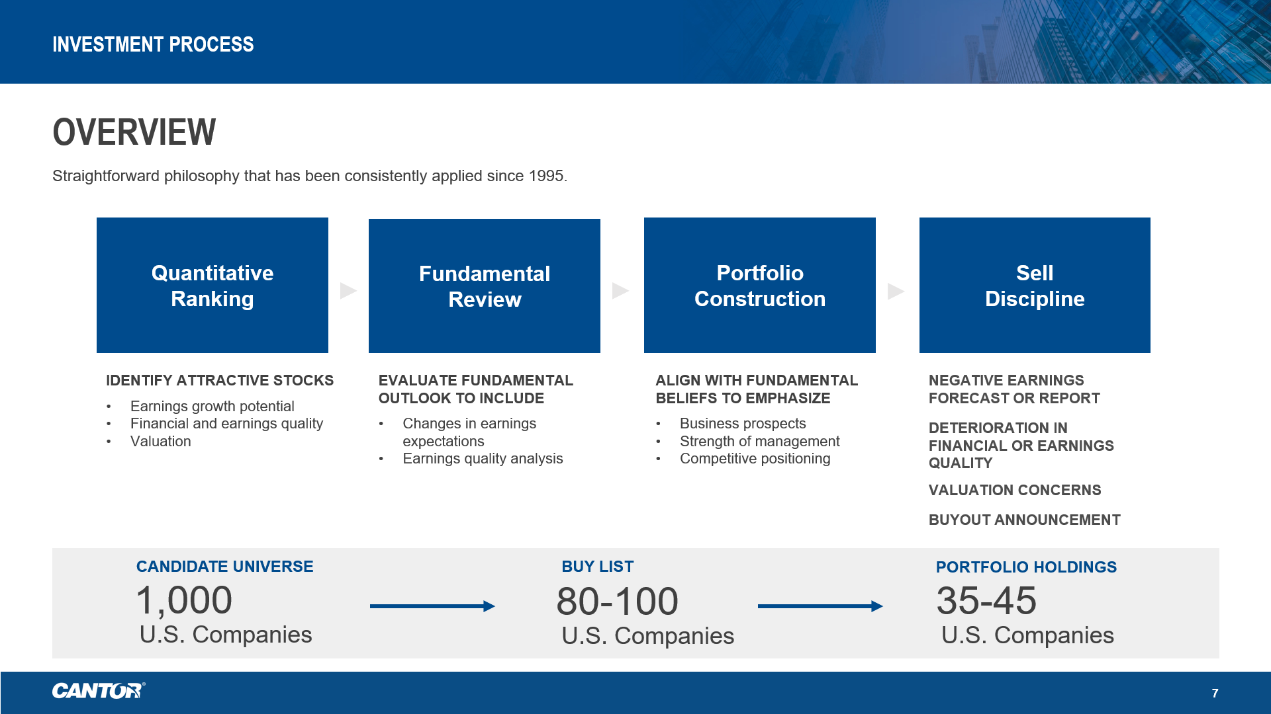

Long Term Results: A Non-Random Walk to Superior Returns
One million dollars invested in Smith Group’s Large Cap Focused Equity portfolio at its founding would today be $28.9 million (see Figure 2 below), net of fees. That same $1 million invested passively in the S&P 500, our primary benchmark, would have become $19.2 million.

Figure 2. Smith Group’s Thirty Years of Beating the S&P 500
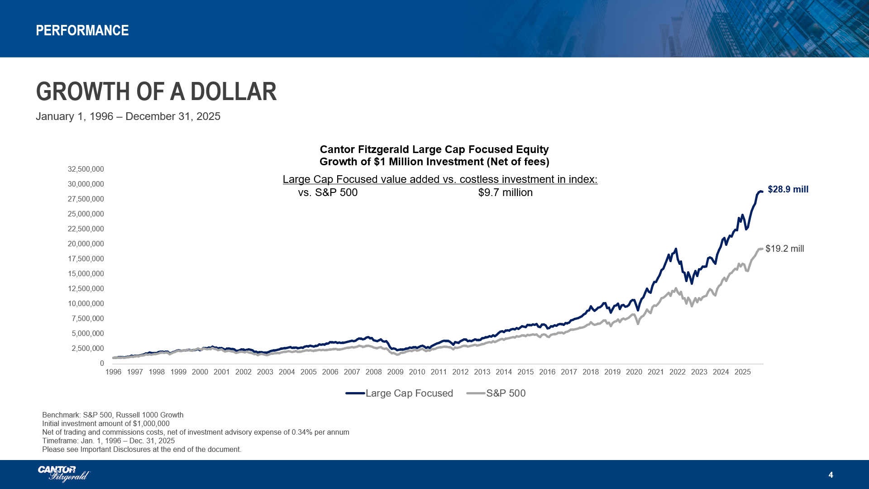

This performance gap is not from a higher beta. We mitigate portfolio risk in six ways:
- Companies must have at least five active analysts posting earnings per share (EPS) estimates.
- Companies must have positive earnings and cannot have the most recent quarterly EPS surprise be negative.
- All companies enter the portfolio at a weighting of approximately 2.5% and are trimmed if the weight increases to 4% (this is a meaningful difference from our benchmark).
- Sector weights in our portfolio must remain within 5% (+ or -) of that sector’s weight in the S&P 500.
- All portfolio factors, such as capitalization size, momentum, etc. are aligned as closely to the benchmark as the eligible company list allows.
- The portfolio’s beta must remain between 0.9 and 1.1, with 1.0 being the target.
Table 1 shows the performance of all our portfolios since inception.
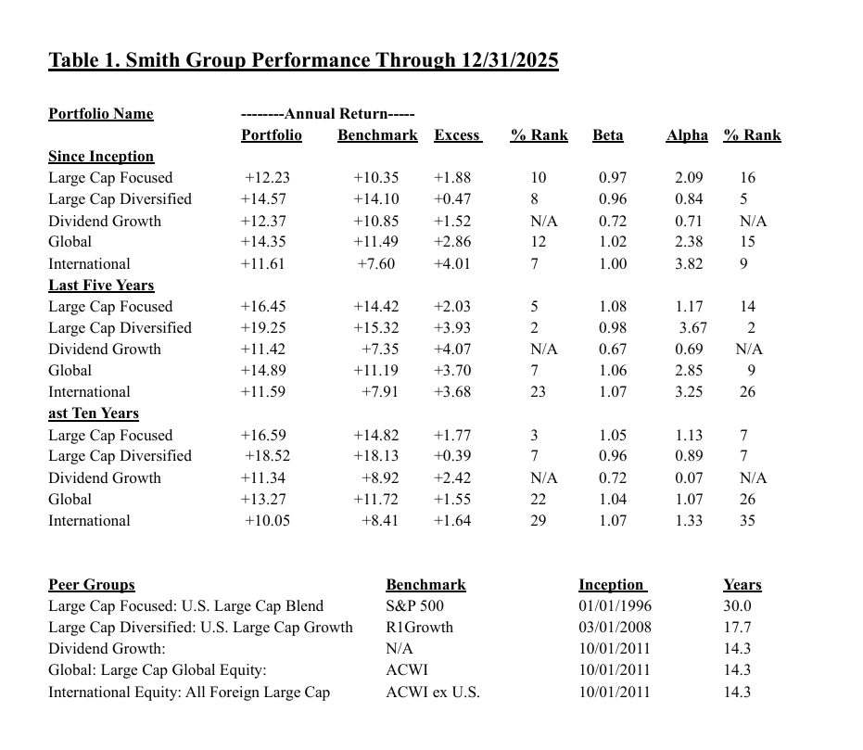

Conclusion: What Does Persistent Outperformance Mean for the Random Walk Hypothesis and for Investors Who Want Better Returns?
The outperformance of Smith Group and other portfolio managers who achieve long-run alpha is not just a rejection of a strict interpretation of the random walk hypothesis. For investors it means that index investing is not a free lunch. Its hidden cost is performance sacrificed to managers who have successfully identified mispriced factors and incorporated them into portfolios. It is the opportunity cost of an absolutist belief that stock prices only move randomly.

DISCLOSURES
Firm: Originally founded in 1995, Smith Group Asset Management, LLC is now part of Cantor Fitzgerald Investment Advisors, L.P., an SEC registered investment adviser a wholly-owned subsidiary of Cantor Fitzgerald, L.P., starting in July 2021. Smith Group is a registered investment advisor that specializes in equity investment management services. The firm manages assets for a diverse list of clients, which includes foundations, endowments, corporate pensions, public funds, multi-employer plans and high-net worth individuals. Effective Jan. 1, 2006, the firm was redefined to exclude wrap SMA business.
Internal Dispersion: Internal dispersion is calculated using the asset-weighted standard deviation of all portfolios that were included in the composite for the entire year.
Three-year Annualized Standard Deviation: Measures the variability of the composite and the benchmark returns over the preceding 36-month period. For periods in which 36 monthly returns are not available, the three-year annualized ex-post standard deviation of the composite is not presented.
Currency: Valuations and returns are computed and stated in U.S. dollars.
GIPS ® Compliance: Smith Group claims compliance with the Global Investment Performance Standards (GIPS®) and has prepared and presented this report in compliance with the GIPS standards. Smith Group has been independently verified for the period Jan. 1, 1992 - Dec. 31, 2024. The verification report is available upon request. A firm that claims compliance with GIPs standards must establish policies and procedures for complying with all the applicable requirements of the GIPs standards. Verification provides assurance on whether the firm's policies and procedures related to composite and pooled fund maintenance, as well as the calculation, presentation, and distribution of performance, have been designed in compliance with the GIPs standards and have been implemented on a firm-wide basis. Verification does not provide assurance on the accuracy of any specific performance report.
Performance Composites: The performance presented is the trade date time-weighted total return including both capital appreciation and reinvested dividends. The composite reflects all accounts managed in an active fully discretionary manner in accordance with the strategy. Smith Group performance is the total return including cash and cash equivalents, gross of fees, of an asset-weighted composite of all fully discretionary portfolios. Accounts are added to the composite at the beginning of the first quarter after full investment of the account. Accounts are removed from the composite at the month end prior to change in account status. Performance shown in the composite is based on actual portfolios, no simulated or back-tested performance is included. In addition to this composite Smith Group also maintains numerous other performance composites. A list of pooled funds and composites descriptions are available upon request.
Net of fee performance: Reflects the deduction of the maximum applicable fixed rate fee level for the referenced portfolio. All performance returns include the impact of cash, cash equivalents, dividends and interest. This fee is deducted in equal installments on a quarterly basis. This fee may be revised periodically. The historic performance, net of advisory fees, can be calculated by subtracting from the performance shown the fee appropriate for your situation. The fee varies based on the level of assets managed for each client. To find the fee that applies to your situation, please refer to Smith Group's Form ADV Part II. If you need assistance in the calculation of the net of fee performance, Smith Group will be glad to assist you.
Net of Max Fee shown reflects the deduction of 2.50% maximum advisory charged by separately managed account platform sponsors plus the maximum fee charged by Smith Group for platform accounts for a total annual fee of 3.00%, allocated quarterly. The fee rate is believed to be representative of the maximum applicable fixed rate advisory and platform access fee level any investor would pay.
Holdings, Economic Sectors and Characteristics: It should not be assumed that recommendations made in the future will be profitable or will equal the performance of the securities and economic sectors shown. A list of recommendations made within the last twelve months is available upon request. The information shown is not intended nor should it be construed to be a recommendation to buy or sell an individual security or economic sector. Any portfolio characteristics or holdings that are shown are intended to present the portfolio as it existed on the date of the report. You should not assume that these same characteristics or holdings will exist in the future.
Earnings Surprise: According to many academic studies, earnings surprise has had a positive relationship to relative performance in most time periods and for most companies. However, this does not mean that this relationship exists for all time periods and for all companies. In the recent past, periods coinciding with an inverse relationship between earnings surprise and relative performance have typically been periods in which corporate earnings are not the focus of investors’ attention. Additionally, companies which have had a chronic negative relationship between earnings surprise and relative performance are typically those companies whose earnings are not product-driven, such as commodity companies. There is no assurance that the historic positive relationship between earnings surprise and relative performance will exist in the future. Nor is there any assurance that the historic ability of Smith Group to forecast a high rate of positive earnings surprise companies will exist in the future.
Policies for valuing investments, calculating performance, and preparing GIPS Reports are available upon request.
GIPS Registered Trademark: GIPS ® is a registered trademark of CFA Institute. CFA Institute does not endorse or promote this organization, nor does it warrant the accuracy or quality of the content contained herein.
Past performance is not indicative of future results. As with any investment vehicle, there is always a potential for profit as well as the possibility of loss. Actual results may differ from composite returns, depending on account size, investment guidelines and/or restrictions, inception date and other factors. Nothing contained in this presentation should be construed as a recommendation to buy or sell a security or economic sector. This material is for your own personal information, and we are not soliciting any action based upon it. The material is based upon information we consider reliable, but we do not represent that it is accurate or complete and it should not be relied upon as such.
Definitions
P/E (price/earnings) ratio is a valuation ratio of a company’s current share price compared to its earnings per share. In this case, P/E is calculated using consensus forecasted earnings per share for the next 12-months. Weighted average market capitalization is a measure of the sum, weighted by Fund position weight, of the total market capitalizations of the Fund holdings. Median market capitalization is the sum of the total value of a company’s outstanding shares multiplied by the price of one share. EPS (earnings per share) growth is a measure of the sum, weighted by Fund position weight of the change in earnings per share reported by the company over a specific time period. Portfolio turnover is calculated as the lesser of the value of all purchases or sales divided by the average of the Fund’s total holdings. Holdings is a count of all Fund holdings excluding any cash or cash equivalents held by the Fund.
Composite Definition: Cantor Fitzgerald Large Cap Focused Strategy (fka Cantor Smith Large Cap Focused; Smith Large Cap Core/Growth)– It is comprised of accounts whose primary objective is growth of principal by investing primarily in stock of large capitalization U.S. companies. Inclusion in this composite requires that accounts are in general not missing in excess of 5% of the firm’s recommended portfolio. A portfolio manager will review for appropriateness of inclusion in the composite any account maintaining a cash position greater than 10% or missing in excess of 5% of the firm’s recommended portfolio. The primary benchmark for these accounts should be the S&P 500 Index and the secondary benchmark should be the Russell 1000 Growth Index. The inception date for the composite is Jan. 1, 1992. The creation date for this composite is Jan. 1, 2004. At this time, the composite containing accounts that directed trading was closed, and those accounts were added to the composite containing accounts in which Smith Group has discretionary trading authority, creating a composite of all accounts invested in this particular strategy. Accounts are added to the composite at the beginning of the first calendar quarter after full investment of the account. Accounts are removed from the composite at the month end prior to change in account status.
Fee Schedule: Fixed Rate: 0.60% on all managed assets effective April 1, 2019. For all prior periods: 1.00% on the first $10 million of assets, 0.75% on the next $15 million of assets, 0.50% on all amounts over $25 million. Variable Rate: 0.25% plus 25% of the excess return over the S&P 500 Index. Charged quarterly in arrears for the trailing 12-month period.
Performance Notes: Gross of fee performance figures shown above do not reflect the deduction of investment advisory fees. Cash, cash equivalents, dividends and interest are included in results. Actual client returns will include deductions for advisory fees. For further disclosure regarding our fees, refer to our Form ADV, Part II.
Benchmarks: The S&P 500 index and Russell 1000 Growth index are unmanaged indices of the shares of large U.S. corporations. They include reinvested dividends and are presented gross of fees.
Principal Investment Risks: The loss of your money is a principal risk of investing in the Strategy. Investments in the Strategy are subject to investment risks, including the possible loss of some or the entire principal amount invested. The Strategy is subject to certain risks, including the principal risks noted below, any of which may adversely affect the Strategy’s value and ability to meet its investment objectives. An investment in the Strategy is not a deposit or obligation of any bank and is not insured by the FDIC or any other government agency. Market risk — The risk that all or a majority of the securities in a certain market will decline in value because of factors such as adverse political or economic conditions, future expectations, investor confidence, or heavy institutional selling. Growth stock risk — Growth stocks reflect projections of future earnings and revenue. These prices may rise or fall dramatically depending on whether those projections are met. These companies’ stock prices may be more volatile, particularly over the short term. Limited number of securities risk — The possibility that a single security’s increase or decrease in value may have a greater impact on the value and total return because the Strategy may hold larger positions in fewer securities than other strategies. In addition, a Strategy that holds a limited number of securities may be more volatile than strategies that hold a greater number of securities. Sector risk — The risk that the value of securities in a particular sector will decline because of changing expectations for the performance of that sector. Active management and selection risk — The risk that the securities selected by a Strategy’s management will underperform the markets, the relevant indices, or the securities selected by other strategies with similar investment objectives and investment strategies. The securities and sectors selected may vary from the securities and sectors included in the relevant index.

